
The New World Dis-order, brought to you by a Globalist
Cabal to Uproot, Confuse and Control the World

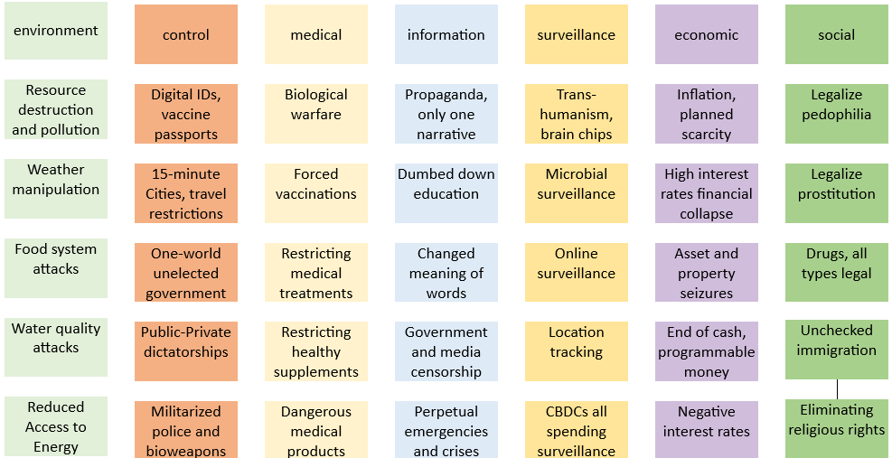

Go to www.preventgenocide.org/C3
Join C3

